NEEDS YOU!
YOUR UNI
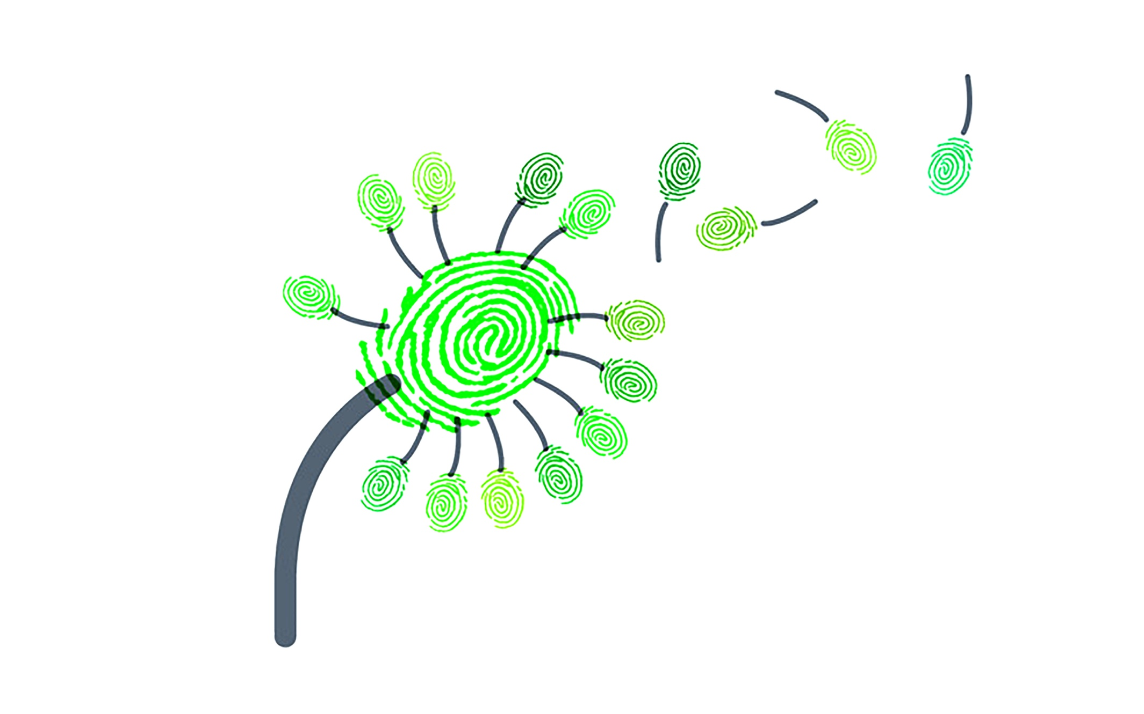

Green Impact
Be part of a Green Impact team! Take part in an international, award winning sustainability change and engagement program.

Get involved, be part of the Sustainability Plan
Recognise your achievements
Engage with your department + the wider uni community
Easy, simple, clear actions
Now! It’s time to make a positive IMPACT!

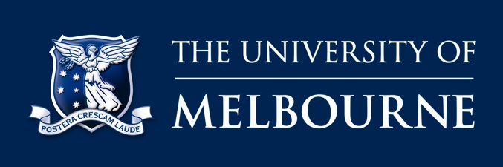 | SIGN UP YOUR TEAM TODAY!  sustainablecampus.unimelb.edu.au/greenimpact

