UoM Waste Assessment Checklist
Step One. Read parts 1 & 2 of the waste assessment checklist
Step Two. Map out the bins in your office/department. If your team are spread over several flours, consider choosing a few on each floor in high traffic areas (e.g., the kitchen) to audit.
Step Three. Conduct a bin-by-bin waste audit. Note which items are contaminating each bin, as well as the condition of the bin signage.
Step Four. Estimation the percentage of your bin contents that are contaminating items. Between 5-10% is acceptable. If you are higher than 10%, consider what changes you can make in the office. You can find recommendations on page 11 of this document, or please do not hesitate to email sustainable-campus@unimelb.edu.au for further assistance.
Step Five. Implement the recommendations.
Step Six. Conduct a Waste Audit in 3 months’ time to see if your area has improved.

1. Introduction
Conducting waste audits on a regular basis helps to identify opportunities for improving workplace practice, reducing waste and increasing reuse and recycling. Below is an assessment template, designed to encourage discussion around waste and recycling practices. Not all fields may be applicable to all workplaces or departments. Please feel free to adapt and edit the checklist to suit your needs accordingly. If you have any questions please feel free to contact the sustainability team: sustainable-campus@unimelb.edu.au.
Determine which area your assessment will cover, whether this is the entire faculty/building or a representative sample such as one floor. For example, conducting an assessment of a whole building may be overly ambitious in one sitting and so it may be best to be conducted in stages.
Estimated Duration: a waste assessment of one floor should take approximately 30 min.
**If you print this template, ensure it is printed double-sided and black and white**

2. How Waste and Recycling works at UoM
Prior to undertaking your assessment, it may be helpful to understand how waste is handled at UoM. There are six waste streams and three main waste streams. All posters can be found here: https://sustainablecampus.unimelb.edu.au/resources
1. Mixed Recycling. All recyclable items should be place in in the bins marked 'mixed recycling' labelled in yellow. Such waste should be dry and largely food-free.
- Paper and cardboard (large cardboard boxes can be disposed of in skips around the university)
- Cardboard and paper containers
- Glass bottles and jars
- Tins and cans (do not crush cans before placing in the recycling)
- Hard plastic containers and bottles
- Aluminium containers and foil (must be scrunched into a loose ball no smaller than the size of a tennis ball)
NO FOOD SCRAPS. Items must be emptied and cleaned of food residue before going into the recycling.

2. Landfill Waste. Includes items like food-contaminated containers, polystyrene packaging that cannot be returned to the supplier, used tissues and other litter, go in the bins marked in red.
- Paper towel, tissues and serviettes
- Soft plastics including plastic packets, bags, wrap and wrappers
- Bioplastics including Biopak packaging
- Disposable cups, including all take-away coffee cups
- Cutlery, chopsticks and straws including those made from plastic and bamboo
- Food waste where an organics bin is not available.
DO NOT place e-waste in the landfill bin. For more information on e-waste visit the Sustainability website.
3. Organics and compost. These bins are located in selected areas of the university. These are collectively gathered and processed in a large communal food waste processor located at Union House. The output is then taken off-site to be matured and mixed with other organic materials before being used as a soil amendment.

A food waste disposal system can be easily set up in your faculty. Select a suitable container that works for you, is easy to carry and clearly labelled. This can then be placed in your kitchen counter or break-room.

Two other common options for disposal include:
- Bringing the compost home for personal use
- Donating the compost to UoM community garden

4. Batteries are one of the most common forms of hazardous waste at the university. To safely dispose of batteries please locate your nearest battery bucket on the Sustainability website.

5. E-Waste. In addition, specialised e-waste disposal buckets can be found across the university. These are for small electronic items such as earphones, IT equipment and hand-held devices.

6. Soft-Plastics Bin. It is important to separate soft plastics from landfill streams to be sent to a specialty recycler. In Australia REDcycle collects post-consumer soft plastics for recycling into a range of products, from fitness circuits to sturdy outdoor furniture, to bollards, signage and more.

3. department information

3.1 Basic Information

DATE of waste assessment (dd/mm/yyyy) | / /
AREA covered (fill in each box) | Department/Faculty | Building Name | Floor / area
Team Representative
Building cleaning times (am, pm, during the working day?)
Approximately how many people use these bins in total?

3.2 General Visual Inspection of Bins

Evidence
Bin type | Number of bins | Is UoM’s standard signage in use? | Is the signage up to date?
Waste
Recycling
Under-desk bins
Organics
Soft plastics |  | N/A
E-waste

Awareness and communications

Criteria | Yes/No | Evidence/comments
Are there any additional posters or other materials used to remind building users of good practice?
Do they have the right bin liners in each bin (black for landfill and clear for recycling)?
Have email updates or similar communications been sent to members of the department, to ensure that they’re familiar with the best way to dispose of waste and recycle?

other waste streams

If the department does not have dedicated e-waste, organics or printer cartridge disposal, soft plastic bin, what is the reason for this?
Bin type | Organics | Soft plastic | E-waste
Do not want to change established procedures
Cannot afford changes to bins at this time
Did not know about the organics, e-waste and printer cartridge disposal
Does not have space for extra waste systems
Do you want to change this?

4. Visual Inspection of bin contents
Conduct a general visual inspection by estimating the percentage of the categories (e.g waste/landfill items) in each bin. Alternatively, you can take photos of your inspection, distribute them to your team and get an average, more accurate estimation of each of the fields. Practice bins can be found on page 10.

*Tips:
- If there is a large building, only do a representative sample of bins
- Small amounts (ie 5% of total) of contaminants is deemed acceptable
- In the contaminants section above make sure you say what the contaminant materials are and what proportion do they make up of the waste.
- If you are over a certain percentage of contaminants, steps must be taken. If you identify what are the contaminants, this will focus on how behaviour can be changed.

4.1 Examples of Bins
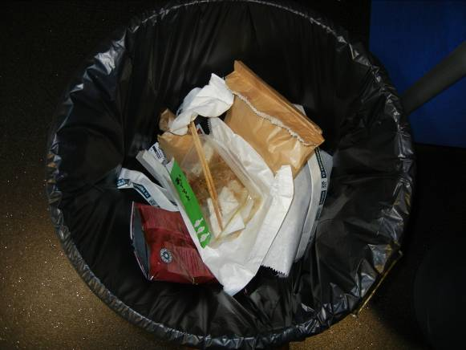
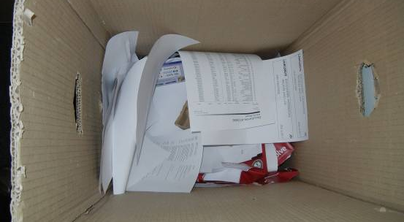
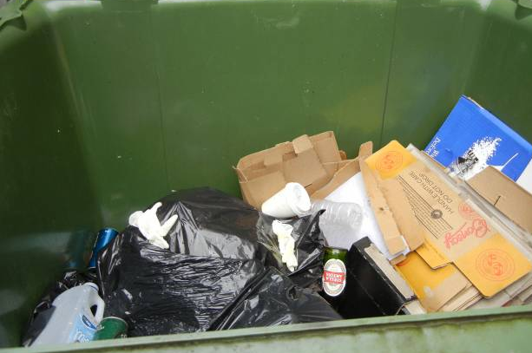
Landfill Bin

Recycling Bin
Paper Recycling Bin
Landfill Bin
Paper Recycling Bin

4.2 Contamination assessment – landfill waste

Bin No | 1 | 2 | 3 | 4 | 5 | 6 | 7 | 8 | 9 | 10
Bin Location
What are the contaminated items?
Food scraps (these should be composted)
Recyclable items (cardboard, paper, hard plastic bottles)
Soft plastics (sheets, bags, packaging)
Batteries, toner cartridges and electrical items (these should be recycled in dedicated bins)
Miscellaneous
Overall Contaminants %

4.3 Contamination assessment – recycling waste
Bin No | 1 | 2 | 3 | 4 | 5 | 6 | 7 | 8 | 9 | 10
Bin Location
Wet food covered materials, plastic wrappers or tissues
Batteries, toner cartridges and electrical items (these should be recycled in dedicated e waste bins)
Other contaminants
Overall Contaminants %

4.4 Contamination assessment – food waste
Bin No | 1 | 2 | 3 | 4 | 5 | 6 | 7 | 8 | 9 | 10
Bin Location
Overall Contaminants %
Non-biodegradable materials like packaging or plastic wrappers

Any meat or heavily based liquid food

Any explicitly recyclable materials (paper, etc)
Other contaminants

4.5 Contamination assessment – other bins

Bin No | 1 | 2 | 3 | 4 | 5 | 6 | 7 | 8 | 9 | 10
Bin Location
Bin Type
Overall Contaminants %

5. Questions and reccomendations to consider
How high is waste contamination as an overall average in the faculty/building (note 5-10 % of contamination is acceptable)?

Consider the questions below and follow the recommendations to reduce contamination:
Question | Yes/No | Recommendations
Does the faculty produce a large amount of a particular waste item? |  | Ask the head of the faculty to reduce consumption in this waste item  Team has engaged with their suppliers to reduce the amount of packaging in their products
What are some easy measures to reduce that particular waste item(s)? | N/A | Have campaigns or information sessions  When the team hosts events to ensure that the waste is minimal and reusable crockery is used  To encourage the team or the team provides it to have reusable cups, plates, crockery for them to use  Teams can share left-over food recipes via social media  The department has a dedicated 're-use' area where staff can donate unwanted personal items for reuse by other staff, for example but not limited to books, clothing, kitchen wear, crafts, food, umbrellas etc.  GI: Office items can be re-homed using the University's Reuse Service.  To try and 'walk the talk' at home, 2 or more Green Impact team members have tried to reduce or even avoid food and packaging waste at home over a prolonged period of time (minimum 3 months)
Are the bin streams being properly used for landfill and recycling? |  | Label bins with the correct signage. Ensure it is visible (e.g. on the walls above the bins)  Have a workshop with your department on how to use the bins correctly and where they are all located
Are desk bins in place across the faculty? |  | The team can purchase office bins  GI: Office bins can be order via campus assist.
Can waste signage be improved? |  | GI: Bin Posters can be ordered via UoM SC resources: https://sustainablecampus.unimelb.edu.au/a-z/r/resources
Can any complementary waste streams be easily added? |  | Book service now to set up an e-waste collection.  Contact sustainable-campus@unimelb.edu.au to use the biodigester for compost scraps  Organise a RedCycle drop off within your team

